Planning Section

An Bord Pleanála,
64 Marlborough St.,
Dublin 1.
16/10/2024
Re: ABP-320487-24 Substitute Consent Application Ballivor, Carranstown, Bracklin & Lisclogher Bogs in Co. Meath and Westmeath
Dear Sir/ Madam,
I refer to your letter dated 08/08/2024 regarding an application from Bord Na Móna for a Substitute Consent which was received by An Bord Pleanála for decision under Section 177E of the Planning & Development Acts 2000-2024. It relates to peat extraction and all peat extraction related activities from 1988 to present day within the Ballivor Bog Group at Ballivor, Carranstown, Bracklin, Lisclogher and Lisclogher West Bogs in Co. Meath and Co. Westmeath. This application is accompanied by a remedial Environmental Impact Assessment Report and a remedial Natura Impact Statement.
Industrial scale peat extraction ended in 2020 and there are on-going decommissioning and maintenance activities associated with the removal of existing peat stockpiles from the Bog Group and duties under IPC licence and post-peat rehabilitation of the Bog Group.
The bogs encompass an area of 2,421 ha while 378 ha were subject to peat extraction at the point of cessation in June 2000. It is stated that Bord na Móna will not be resuming peat extraction at any time.
The project phases are described as follows:
- ‘Peat Extraction Phase’: peat extraction activities and all ancillary works at the Application Site from July 1988 to the cessation of peat extraction in June of 2020 (July 1988 – June 2020).
- ‘Current Phase’: the management of the Application Site since June 2020 (June 2020 to present).
- ‘Remedial Phase’: the activities intended to be carried out at the Application Site into the future.
The works undertaken on the site are:
- Installation of surface water drainage infrastructure at Ballivor Bog Group, specifically at Ballivor, Carranstown, Bracklin, Lisclogher, and Lisclogher West Bogs to facilitate peat extraction activity from 1988 to June 2020;
- Vegetation clearance to facilitate peat extraction activity from 1988 to June 2020;
- Industrial scale peat extraction (milled peat and sod peat/moss), specifically at Ballivor, Carranstown, Bracklin, and Lisclogher Bogs from 1988 to June 2020;
- Use and maintenance of pre-existing ancillary supporting infrastructure and services to facilitate peat extraction and associated activities (e.g., railway infrastructure, fixed fuel tanks, drainage (drains, silt ponds, pumps), machine passes etc.), from 1988 to present day;
- Control Measures associated with the above, inclusive of the IPC Licence measures (Ref. P0501-01) which commenced from April 2000 onwards to the present day;
- All associated site development and ancillary works.
It is stated that all existing stockpiles of peat were removed off the bogs by the end of 2023. No peat extraction works are occurring at the application site in the current phase. The remedial phase of the project involves the implementation of Cutaway Bog Decommissioning and Rehabilitation Plans as per IPC Licence.
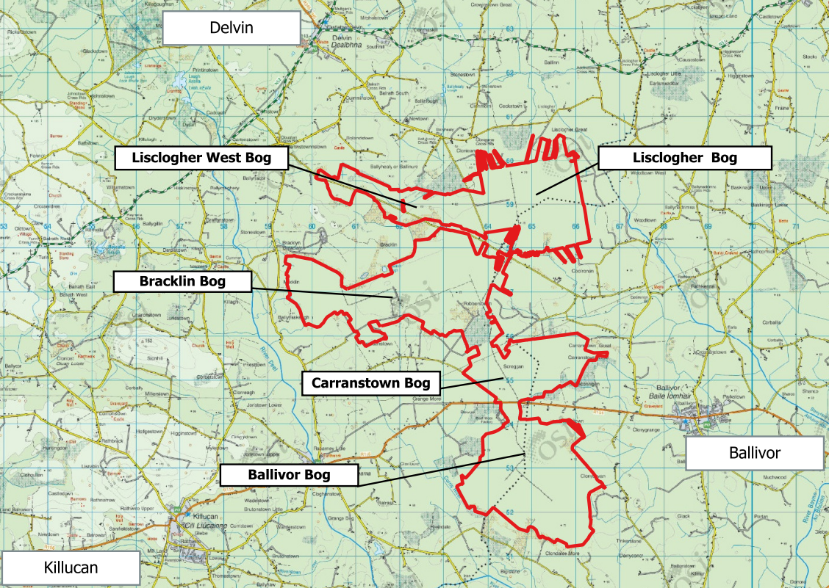Fig. 1: Site Location
This submission is the report of Meath County Council’s Planning Dept. under Section 177I (1) of the Planning & Development Acts 2000 and the items listed at Section 177I (2)(a), (b), (c), (d) and (e) and the reference to Circular Letter PL 8/2013. I note your letter of acknowledgment dated 10/09/2024 which relates to MCC’s earlier submission.
The comments from MCC address the items at Section 177I:
(a) information relating to development (including development other than the development which is the subject of the application for consent) carried out on the site where the development the subject of the application for consent is situated, and any application for permission made in relation to the site and the outcome of the application;
The following Planning History is relevant to this application:
- ABP-316212-23 (Live SID Application) for 26 wind turbines and associated works at the Ballivor Bog Group, County Meath and County Westmeath – Ballivor Wind Farm. https://www.pleanala.ie/en-ie/case/320487
- ABP-311565-22 (Granted SID Application) for 9 turbines and all associated works at Ballagh, Billistown, Ballynacar and Bracklin, County Westmeath and Coolronan, County Meath. https://www.pleanala.ie/en-ie/case/316212
- ABP-318979-24 Pre-App Discussions pursuant to Section 177E(IA) of the Planning and Development Act 2000, as amended for historical peat extraction and all associated works within the Ballivor Bog Group at Ballivor, Carranstown, Bracklin, Lisclogher and Lisclogher West bogs, Counties Meath and Westmeath. https://www.pleanala.ie/en-ie/case/318979
Several planning applications are identified in the EIAR associated with ABP-316212-23 within Co. Westmeath, as follows:
- 21620 (Westmeath Co. Co.) - Retention permission granted for continued use of an existing Guyed Wind Monitoring Mast with instruments, 100m in height on its lands at Lisclogher Bog, Lisclogher Great, Co. Westmeath for a further period of three years. The purpose of the mast is to assess the suitability of the company's adjacent lands for wind farm development.
- 166259 (Westmeath Co. Co.) - Permission granted to erect a guyed wind monitoring mast with instruments up to 100m in height. The purpose of the proposed mast is to assess the suitability of the company's adjacent lands for wind farm development.
- 156135 (Westmeath Co. Co.) – Permission granted to erect a guyed wind monitoring mast, with instruments, up to 100m in height, at Lisclogher Bog, Lisclogher Great, Co Westmeath. The purpose of the proposed mast is to assess the suitability of the company's adjacent lands for wind farm development.
- ABP-311646-21 (An Bord Pleanála) – Application for Leave to Apply for Substitute Consent for peat extraction and all peat extraction related activities. Should this be granted, the NIS states that it will be accompanied by an EIAR, AASR and NIS will assess the impacts of historical peat extraction activities on biodiversity and Designated Sites.

- Other Consents (IPC) - The EIAR with ABP-316212-23 refers to ongoing site management and environmental management (as per EPA Integrated Pollution Control (IPC) Licence P0-501) and temporary wind measurement (via 100m meteorological mast on Lisclogher Bog). Active peat extraction under the IPC Licence ceased within the area of the wind farm site in June 2020, but the stockpiled peat continues to be removed off the bogs and was completed by 2024.
  - IPC Industry Licence P0506-01 and P0507-01 for Bord na Móna Energy Ltd. (Kilberry) are identified to the west of the Meath Co. boundary.
  - Draft Cutaway Bog Rehabilitation and Decommissioning Plans 2022 (ABP-316212-23 EIAR Appendix 6-6) were prepared for Ballivor, Bracklin, Carranstown and Lisclogher Bogs and the impact of the proposed development on the restorative/ permanent rehabilitation plans which were prepared in accordance with Condition 10.2 of IPC Licence Ref. P0501-01 following the cessation of peat extraction should be considered by An Bord Pleanála.
    - The Ballivor Wind Farm Application (ABP-316212-23) stated that said Plans would be carried out alongside or after the proposed windfarm construction.
    - An Bord Pleanála my wish to consult the EPA regarding the IPC Licence.
(b) information relating to any warning letter, enforcement notice or proceedings relating to offences under this Act that relate to the applicant for substitute consent;
None in Co. Meath.
(c) information regarding the relevant provisions of the development plan and any local area plan as they affect the area of the site and the type of development concerned;
Planning Policy
In addition to the Meath County Development Plan and details set out below, An Bord Pleanála’s attention is drawn to the following Directives, Policy documents:
- EU Directive 2009/28/EC and Directive 2018/2001/EU (Renewable Energy)
- Ireland 2040 National Planning Framework
- Action Plan for Jobs and Future Jobs Ireland 2019
- Strategy for Renewable Energy: 2012-2020
- National Climate Change Adaptation Framework (NCCAF) (2012)
- Climate Action and Low Carbon Development Act (2015)
- National Mitigation Plan 2017
- National Adaptation Framework 2018
- National Renewable Energy Action Plan Ireland 2020
- National Climate Action Plan 2024
- National Peatland Strategy
- National Raised Bog SACs Management Plan 2017-2022
- National Biodiversity Action Plan
- Eastern & Midland Regional Assembly Regional Spatial & Economic Strategy (RSES), 2019 to 2031
- Wind Energy Guidelines (DoEHLG, 2006) & Revised Draft Guidelines (2019)
- Just Transition Fund for the Midlands Region
- Meath County Development Plan 2021-2027
- Meath Climate Action Strategy
- Meath Climate Action Plan 2024-2029
- Meath County Council Economic Strategy
- Other Relevant Guidelines/ Guidance
- Draft Cutaway Bog Rehabilitation and Decommissioning Plans to be agreed with the EPA prior to implementation.

The following Meath County Development Plan 2021-2027 Policies and Objectives are of note:
  - Section 10.5.5. Agriculture and Land Use – Maintaining and improving the quality of peatland to reduce their emission.
  - Section 8.11 Peatlands –
    - HER POL 45: To ensure that peatland areas which are designated (or proposed for designation) as NHAs, SACs or SPAs are conserved for their ecological, climate regulation, archaeological, cultural and educational significance.
    - HER OBJ 39: To work in partnership with relevant stakeholders on a suitable peatland site(s) to demonstrate best practice in sustainable peatland conservation, management and restoration techniques and to promote their heritage and educational value subject to Ecological Impact Assessment and Appropriate Assessment Screening, as appropriate, having regard to local and residential amenities.
  - Section 8.19 Green Infrastructure – refers to the strategic importance of a planned and managed network featuring areas with high quality biodiversity (uplands, wetlands, peatlands, rivers and coast)….described as the County’s ‘Green Infrastructure’.

(d) any information that the authority may have concerning—
(i) current, anticipated or previous significant effects on the environment, or on a European site associated with the development or the site where the development took place [or, where section 177E(2A)(b) applies, is proposed to take place] and, if relevant, the area surrounding or near the development or site, or
(ii) any remedial measures recommended or undertaken;
An Bord Pleanála is invited to consider the following:

- Site Attributes - Topography is generally flat in the area but ranges between c. 68 – 86 metres above ordnance datum (m AOD).

Current access to the site is via several local roads in Co. Meath and Westmeath and the area is dissected by the R-156, which is a straight regional road. The road is crossed by the peat rail line with areas which were subject to commercial peat production visible in the background of Fig. 1.

Residential dwellings and farmsteads are located along the L-80124-0 (local road), L-80122-10 (local road) and R-156-0 in the townland of Robinstown, L-40161-21 (local road), L-80181-7 (local road) and L-80182-0 (local road) in the vicinity of the site (Co. Meath).

A 110kV overhead line from Mullingar to Corduff traverses the proposed development site at Carranstown Bog.

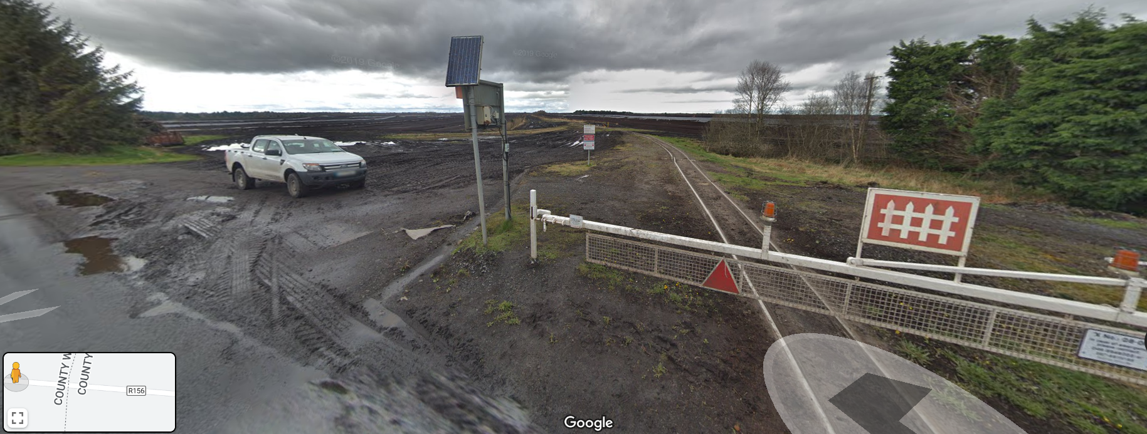
Fig. 2: View to the north from R-156, Co. Westmeath, immediately west of the border with Co. Meath (c. Google 2023)

- Rural Area - The land within the boundaries of Meath County Council is identified as ‘Rural Area’ and ‘low development pressure area’ in the Meath County Development Plan (CDP) 2021-2027 and lands within the boundaries of Westmeath County Council are classified as ‘unzoned’ lands as per the Westmeath CDP.

- Land use/ Cover - Land use within the site is synonymous with long-term intensive, industrial peat extraction however this is now in the decommissioning phase. The landscape is that of large open peatlands/ cutover bog surrounded by agricultural lands with native hedgerow and trees.

The EIAR for ABP-316212-23 describes the landcover as a mixture of bare cutaway peat, re-vegetated bare peat, degraded blanket bog, scrub, low woodland and remnants of high bog. 18.9km of Bord Na Móna permanent fixed gauge rail lines can be found running through Ballivor, Bracklin and Carranstown Bogs. There are rural dwellings in the vicinity on adjoining roads.

The lands comprise 4 large cutover raised bogs, with Lisclogher and Bracklin Bog to the north, Carranstown Bog in the middle and Ballivor Bog to the south.

Large areas of Lisclogher Bog and large parts of Bracklin and Ballivor Bogs, have not be subject to commercial cutting for a significant period of time and thus vegetation, dominated primarily by birch scrub and woodland, common cottongrass and ling heather which has regenerated over much of these areas.

Other areas, i.e. Carranstown Bog and sections of Ballivor, which underwent peat extraction until relatively recently are characterised by large areas of bare peat. Peat production ceased entirely in June 2020. Small areas of uncut remnant raised bog (6 no. separate fragments) are also present in the site, mostly at the peripheries and outside the footprint of the proposed development.

  - There are small pockets of trees/ wooded areas and lakes close to the north-west boundary of the site – one of which is called Bracklin Lough.
  - Corine data (2018) identifies much of the site as inland wetlands, with some areas of forest and semi-natural areas (scrub and/or herbaceous vegetation associations).
  - Based on the Teagasc Subsoils Map, the area of the site generally corresponds with a large extent of cut-over peat and some smaller areas on the edges of the peat comprising Chert till (TCh), Limestone till (Carboniferous) (TLs), Limestone sands and gravels (Carboniferous) (GLs).

- Landscape Character - According to the Landscape Character Assessment for County Meath (part of the Meath County Development Plan 2021-2027), the site is within the Lowland Landscape (South-West Lowlands) character area which has a high value and high sensitivity.

It comprises a flat lowland landscape with an expansive network of open peatlands located at the Westmeath-Meath County boundary. Industrial peat extraction practices at the site in the 20th Century have impacted on the character of the landscape within the site. The bogs are now degraded and can be described as a cutover peatland landscape.

- Cultural Heritage (Architecture & Archaeology) - There are no Protected Structures situated within the application site (as per www.archaeology.ie mapping viewer and internal GIS mapping). There are some National Monuments in the vicinity of the site: ME01591 SMRS: ME035-001--- Burial in the Townland of Coolronan and associated Zone of Archaeological Notification (R171864). There are two national monuments (ME01601/ SMRS: ME035-011--- Rath) and ME01602/ SMRS: ME035-012---- Earthwork in the townland of Robinstown which are c. 390m east of the site boundary in Co. Meath. However, An Bord Pleanála may wish to review sites on www.archaeology.ie

There is a listing on the National Inventory of Architectural Heritage is Reg. No. 15402102: Section of Rails in Grange More, Co. Westmeath, which is described as ‘Permanent narrow gauge Bord na Móna railway line, erected c.1952, for transporting turf to the Ballivor Processing Plant, Co Meath. Now only used to transport carriages brought in for servicing. Constructed of steel I beams. Railway line is three foot wide and is laid in ten-yard sections. Level crossing to main road comprises concrete piers with steel cross bars. Much of the earlier permanent narrow gauge is overgrown by vegetation’. It is located to the east of Raharney, close to the border with County Meath. It has a ‘Regional’ rating and is of ‘Social and Technical Interest’.

An Bord Pleanála may wish to consider the impact on Cultural Archaeology/ Heritage associated with the bog. MCC’s Archaeologist recommended a condition for the Ballivor Wind Farm in relation to the recording of cultural heritage in these bogs which could be significantly impacted by the proposed re-wetting.

- Ecological Sites - The nearest NHA is 001584 Mount Hevey Bog (which is also a SAC: 002342) located c. 3.2km south of the boundary of the site. The River Boyne and River Blackwater Special Area of Conservation (SAC: 002299) and Special Protection Area (SPA: 004232) are located c.445m north of the site boundary (Stonyford River).

In its AA Screening and Natura Impact Statement, An Bord Pleanála are requested to consider the impact on ornithology, otters, etc. and SCIs, QIs associated with the SAC and SPA in its NIS and EIAR. Indirect effects, in the form of disturbance, due to site activities as this may impact on the otter population associated with the SAC, birds or other species.

The Ballivor Wind Farm EIAR included a hydrological assessment of potential impacts on local designated sites. The River Boyne and River Blackwater SAC and SPA is hydrologically connected to the site, as the Deel, Stonyford and Boyne Rivers are in the vicinity/ downstream of the site. Following implementation of appropriate mitigation measures, no significant impacts on the European Sites were identified.

Features which are of county importance and do not have specific designation provide several ecosystem services. Such sites can function as important stepping-stones and ecological corridors (Article 10 of the Habitats Directive) for improving the ecological coherence of sites protected for nature conservation. A Habitat Management and Enhancement Plan (HMEP) is recommended in addition to any Cutaway Bog Decommissioning and Rehabilitation Plans.

It is also recommended that an Ecological Clerk of Works is appointed to advise on, oversee and monitor mitigation measures. All mitigation measures outlined in the EIAR/NIS/EMP should be fully implemented and post-construction monitoring as detailed in EIAR should be in place for a minimum no. of years post construction. Where relevant, mitigation measures should be in line with the NRA Best Practice Guidelines for the Conservation of Bats in the Planning of National Road Schemes and the Guidelines for the Treatment of Bats during the Construction of National Road Schemes and any works relating to bats may only be carried out under a licence issued by the NPWS.

- Watercourses/ WFD/ Drinking Water - The River Deel is located 1.4km south of the site and this is also a tributary of the River Boyne. Tributaries to same (or part of the Curris River) extend into the site. The watercourses on/ adjoining the site are hydrologically linked tributaries to the River Boyne; and the Water Framework Directive (WFD) catchment and sub-catchments over which the site extends are that of the Boyne. WFD water quality status with the Stonyford River tributaries within the site are ‘moderate’; and ‘good’ for the River Deel/ River Boyne tributaries. Groundwater body status is ‘good’.

Potential indirect effects on European Sites due the hydrological connectivity between the site and the River Boyne/ River Blackwater SAC and SPA, due to deterioration in water quality arising from leachate/ or pollutants during the operational and decommissioning phases of the development. A potential pathway for indirect effects on aquatic QIs/SCIs due to operational and decommissioning activities should be considered.

The EIAR submitted for Substitute Consent notes that existing land drains are typically spaced every 15-20 metres with large arterial drains connecting to smaller field drains which slope towards perimeter silt ponds and surface water outfalls. The proposed Plans for rehabilitation will involve the rewetting and revegetation of the drained bogs which has potential to improve the bog environment and downstream water quality.

It is advised that An Bord Pleanála considers surface water protection measures associated with this operational/ decommissioning phase to address:
  - Suspended solids release from bare peat/ soil and peat/ soil storage areas during construction /works, spillage of fuels (hydrocarbons) associated with the refuelling of excavation machinery.
  - Should non-permeable hard-surfaces be required this may result in increased surface water run-off from the site, which in turn has potential to cause erosion of watercourses and impact on water quality. There is also potential for run-off of pollutants due to accidental spillage or release of hydrocarbons from site vehicles.
  - As part of ABP-316212-23, to ameliorate the potential impacts, an Environmental Management Framework was submitted which included comprehensive detail regarding pollution prevention and hydrocarbon management and mitigation measures. Details included drainage (including interceptor drains, swales/ roadside drains, check dams, stilling ponds/ settlement ponds, culverts, IFI (2016) Guidelines on protection on fisheries during construction works in and adjacent to waters, silt fences, further Section 50 applications (Arterial Drainage Act, 1945) and supervision of works by an Environmental Clerk of Works and project hydrologist). Mitigation measures included the avoidance of on-site refuelling, fuel and hazardous materials storage, dust control, etc.

A Surface Water Drainage Plan is recommended. Monitoring of wells within the vicinity may be required to avoid impacts to drinking water supplies and the applicant should be responsible for any remedial actions.

An Bord Pleanála may wish to consider an Art. 4(7) Assessment under the Water Framework Directive.
- Flood Zones - Flood Zones are associated with the rivers and streams (tributaries to the Stonyford River which flows west to east c. 2km north of Ballivor) in the area which drain to the River Boyne SAC 002299 and SPA 004232. A Flood Zone A is associated with the tributary to the Stonyford River in the townland of Coolronan.

The proposal must not contribute to downstream flooding. An Bord Pleanála are invited to ensure that any culverting works are agreed in writing with the Environment Department. Stockpiles are located away from watercourses and outside Flood Zones A & B; and other consent requirements such as Section 50 from OPW may be required.

- Waste/ Resource/ Environmental Management - The need for an EMP (i.e. CEMP), WMP, Waste Management Act 1996 requirements regarding the control of waste, importation of soil, etc. The EMP must address extremes of weather and possible impacts on receptors and mitigation. WMP and EMP are to be treated as live documents.

It is recommended that conditions regarding dust emissions, refuelling, bunding of hydrocarbons, chemicals, etc. away from watercourses, supply of spill kits and hydrocarbon absorbent pads, prohibition of burning of waste on site, details on the management of waste streams, use of low emission vehicles and plant, maintenance of a complaints register, requirements in relation to the importation of soil, stone or topsoil and the storage of such material on site, pre-works invasive species survey and subsequent management plan as necessary; and pre-works survey for protected species.

- Major Accidents/ Peat Stability - An Bord Pleanála are requested to consider A Geotechnical and Peat Stability Assessment and the risk of peat failure in the context of the proposed development. Peat depths vary and a series of control measures are required to manage all risks associated with peat instability. A Peat and Spoil Management Plan is recommended.

- Transport/ Haulage – It is recommended that An Bord Pleanála applies conditions regarding haulage routes and a phasing programme. Road Opening Licences (separate to Planning) may also be required, etc.

- Cumulative Effects – An Bord Pleanála are requested to consider the cumulative and in-combination effects of the proposed development with adjoining wind farm development proposals. For example, it is estimated that approximately 732,000m³ of peat and spoil will be managed during the construction of the proposed Ballivor Wind Farm and it will result in the loss of some habitats of local importance (higher value), including 32.8ha of cutover bog habitats (or 1.9% of the total area of this habitat within the site) due to temporary and permanent elements of the proposed development which is characterised by bare peat, revegetating dry heath and pioneer poor fen communities, as well as smaller areas of revegetating birch scrub and dry bog woodland. 1.03ha (0.3% of the total area of this habitat within the site) of highly degraded uncut remnant raised bog will be lost and 0.28ha of oak-ash-hazel woodland and 375m of hedgerow habitat with scattered trees will be lost.

- Climate Impact – An Bord Pleanála is invited to consider the expected loss of sequestered carbon to the atmosphere due to the changes the peat environment over time (loss of 295 MtCo₂e) and the potential for the bogs to once again become a carbon sink in the remedial phase.
(e) the opinion, including reasons therefor, of the F851[chief executive] as to—
(i) whether or not substitute consent should be granted for the development, and
(ii) the conditions, if any, that should be attached to any grant of substitute consent.
If planning permission is granted, An Bord Pleanála is respectfully requested to attach the conditions listed below. While the conditions relate exclusively to the element of the development proposed in Co. Meath, there is inevitably some overlap with the part of the site in Co. Westmeath.
Schedule of Conditions

- The development shall be carried out and completed in accordance with the plans and particulars lodged with the application to An Bord Pleanála on the XX/XX/XXXX, except as may otherwise be required to comply with the following conditions. Where such conditions require details to be agreed with the planning authority, the developer shall agree such details in writing with the planning authority prior to commencement of development and the development shall be carried out and completed in accordance with the agreed particulars.

Reason: In the interest of clarity and proper planning and sustainable development.

- The period during which the development hereby permitted may be carried out shall be ten years from the date of this permission.

Reason: In the interest of clarity and having regard to the nature and extent of the proposed development, it is considered appropriate to specify a period of validity of this permission in excess of five years.

- (a) The mitigation measures and monitoring identified in the Environmental Impact Assessment Report (including Chapter 17), Natura Impact Statement, Construction Environment Management Plan and other particulars submitted with the planning application, shall be implemented in full by the developer, except as may otherwise be required in order to comply with the following conditions. The developer shall appoint persons with appropriate ecological, hydrological and construction expertise such as Environmental Manager/ Ecological Clerk of Works and Hydrologist to ensure that the mitigation measures identified in the above documents are implemented in full during the pre-construction, construction stage and post construction phases to advise on, oversee and monitor mitigation measures. Monitoring shall be carried out for a minimum of 7 years post construction.

(b) A Habitat Management and Enhancement Plan should be implemented in full, in the event of a grant of permission.

Reason: In the interest of clarity and the protection of the environment during construction and operational phases of development.

- Trees and hedgerows shall not be removed during the nesting season (i.e. March 1st to August 31st) in accordance with the Wildlife Act (as amended). Replacement hedgerows shall be of native species.

Reason: In the interest of avian ecology and visual amenity.
- All landscaping shall take place in the 1st planting season upon commencement of development and shall be in accordance with the plans and particulars as submitted with this application. The landscaping and screening shall be maintained at regular intervals. Any trees or shrubs planted in accordance with this condition which is removed, die, become seriously damaged or diseased within two years of planting shall be replaced by trees or shrubs of similar size and species to those originally required to be planted.

Reason: To protect the rural character of the area.

- The developer shall facilitate the preservation, recording and protection of archaeological materials or features that may exist within the site. In this regard, the developer shall:

  - Notify the planning authority in writing at least four weeks prior to the commencement of any site operation (including hydrological and geotechnical investigations) relating to the proposed development.

  - Employ a suitably-qualified archaeologist in advance of construction works to complete an archaeological assessment of the project site to determine the location, date, nature and extent of any archaeological sites or features. This work will feed into an Archaeological Mitigation Strategy Document that will determine how any archaeological remains are either preserved in situ or preserved by record.

Machine-based trial trench investigations of any areas subject to development are required. Particular attention to be paid:
  - to potential surviving previous county boundary markers,
  - the areas north and south of the R156 (which may contain trackways),
  - proposed turbine bases and access roads.

If the advance works show nothing of archaeological significance, construction works shall be monitored, as stray finds (including human remains) are always a possibility. All finds and reports shall be lodged with the National Monuments Service and the National Museum of Ireland.

  - The suitably-qualified archaeologist shall monitor all site investigations and other excavation works and prepare a report on the results of such monitoring to be submitted to the Planning Authority and to the Department of Arts, Heritage and the Gaeltacht.

  - Employ a suitably-qualified palaeo-environmental specialist to complete a programme of palaeo-environmental research on the whole area of the site. The palaeo-environmental specialist shall guide research under the general supervision of the archaeologist.
Should archaeological remains be discovered on the site in advance of works or during works, the palaeo-environmental specialist shall advise on appropriate sampling and methodologies for preservation in situ or by record.

  - A full written and drawn survey of the Bord na Móna railway in its entire, current condition, including all associated structures and any abandoned rolling stock shall be completed by a suitably-qualified archaeologist.

  - Two folklore surveys shall be completed by a qualified folklore specialist: one from the population on the Meath side and one from the population on the Westmeath side. A baseline for this survey will be the Schools Folklore collection on duchas.ie. Folklore is any oral histories up to the present day.

  - Results of the works outlined above shall be published in digital and/ or hard copy.

  - Provide arrangements, acceptable to the Planning Authority, for the recording and removal of any archaeological material which the authority considers appropriate to remove.

  - A comprehensive report on any completed archaeological excavation shall be prepared and submitted to the Planning Authority and to the National Monuments Service within a period of six months or within such extended period as may be agreed with the Planning Authority.

Reason: To ensure the continued preservation in situ or by record of all archaeological and historical material, features or objects, to conserve the archaeological heritage of the site, it is considered reasonable that the developer should facilitate the preservation and protection or the preservation by record of any archaeological features or materials which may exist within it.

- Prior to commencement of the development, the developer shall submit the following for agreement, to the satisfaction of the Planning Authority:

- Details of proposed haulage route along the local road network.

- Phasing programme for works.

Reason: In the interests of Road Safety and Traffic Management

- The public road shall be maintained clean and free of any dirt or debris created as a result of the proposed development.

Reason: In the interest of traffic safety and proper planning and sustainable development.

- (a) The applicant shall ensure that there shall be no development within 10 metres of the watercourses on site to facilitate ongoing maintenance by the OPW or other parties unless otherwise agreed with the OPW and such agreement shall be submitted in writing to the Planning Authority, in advance of the commencement of development on the site.

(b) The Applicant shall carry out all works in accordance with recommendations in the Inland Fisheries Ireland Guidance Document on Protection of Fisheries during Construction Works in and adjacent to Waters, 2016. Compliance with this condition shall be to the satisfaction of the Planning Authority.

Reason: In the interest of environmental protection and the protection of water quality.

- The Applicant shall update accordingly and communicate to all site personnel an Environmental Monitoring Plan (EMP). The EMP shall include but not be limited to operational controls for dust, noise and vibration, waste management (to include contaminated materials encountered), protection of soils and groundwaters and surface waters (to include a proposal for a surface water monitoring programme to be undertaken during the construction phase), protection of flora and fauna, site housekeeping, emergency response planning, site environmental policy, environmental regulatory requirements and project roles and responsibilities. The EMP shall also address extreme of weather (drought, wind, precipitation, temperature extremes) and the possible impacts on receptors and mitigation of same. The EMP shall be treated as a live document.

Reason: In the interest of environmental protection and orderly development.

- The Applicant shall prepare and implement a Waste Management Plan (WMP) for the proposed development. The WMP shall include but not be limited to project description, legislation requirements, demolition waste, construction phase waste, categories of construction waste, anticipated hazardous waste, non-construction waste, segregation of waste streams, estimated waste generated, waste hierarchy and adherence to same, roles and responsibilities and communication of WMP, details of recovery and disposal sites, details of waste hauliers, record keeping and documentation, waste audit procedures. The WMP shall be prepared in accordance with “Best Practice Guidelines on the Preparation of Waste Management Plans for Construction and Demolition Projects” (2006) and “Guidelines for the Management of Waste from National Road Construction Road Projects” (Rev. 2014), the WMP shall also take cognisance of the current Regional Waste Management Plan in particular to the upper tiers of the Waste Hierarchy. All waste generated on site shall be recovered/ disposed of at an authorised facility and transported by an authorised collector. The WMP shall be treated as a live document and communicated to all relevant personnel.

Reason: In the interest of environmental protection and orderly development.

- Dust emissions at the site boundaries shall not exceed 350mg/m²/day. All mitigation measures in respect of dust as referenced in an updated CEMP shall be fully implemented.

Reason: In the interest of environmental protection and orderly development.

- All refuelling shall take place in a designated refuelling area at least 30m from watercourses, details of same to be included in the updated Construction Environmental Management Plan (CEMP).

Reason: In the interest of environmental protection and orderly development.

- All hydrocarbons, chemicals, oils, etc. shall be stored in a dedicated bunded area at least 30m from watercourses and capable of storing 110% of the container/tank capacity.

Reason: In the interest of environmental protection and orderly development.

- The applicant shall ensure adequate supply of spill kits and hydrocarbon absorbent pads are stocked on site.

Reason: In the interest of environmental protection and orderly development.

- Burning of waste, including green waste, is prohibited on site.

Reason: In the interest of environmental protection and orderly development.

- The Applicant shall provide to the Local Authority, on completion of the works, a comprehensive report detailing the management of all waste streams generated during the construction and commissioning stages of the project. This shall include but not be limited to type of waste streams, amount of each waste stream generated, destination of waste streams (including final destination if applicable), percentage of waste re-used, recycled, recovered and disposed, and prevention and minimisation initiatives undertaken.

Reason: In the interest of environmental protection and orderly development.

- The construction works shall be carried out in accordance with the noise guidance set out by BS 5228-1:2009 Code of Practice for Noise and Vibration Control on Construction and Open Sites and the NRA Guidelines for the treatment of Noise and Vibration in National Roads Schemes.

Reason: In the interest of residential amenity.

- The Applicant shall, during the construction stage, maintain a Complaints Register to record any complaints regarding but not limited to noise, odour, dust, traffic or any other environmental nuisance. The Complaint Register shall include details of the complaint and measures taken to address the complaint and prevent repetition of the complaint.

Reason: In the interest of environmental protection and orderly development.

- All excavated material stored onsite shall be setback a minimum of 5 metres back from the drainage ditches/watercourses onsite. A silt fence shall also be installed at a minimum of 3 metres from the drainage ditches/watercourses onsite and shall be maintained until vegetation has been re-established.

Reason: In the interest of environmental protection and orderly development.

- A preconstruction invasive species survey shall be carried out to identify the presence of any invasive species and in the event that they are present, a full Invasive Species Management Plan shall be developed.

Reason: In the interest of environmental protection and orderly development.

- A pre-site clearance survey for protected species shall be carried out across the site a maximum of 3 months prior to site clearance. This shall include an assessment for bat roosts. The applicant shall liaise with the NPWS for appropriate guidance. Any works relating to bats may only be carried out under a licence issued by the NPWS.

Reason: In the interest of environmental protection and orderly development.

- Prior to commencing construction on site, the following issues shall be addressed to the satisfaction of Meath County Council Water Services Department.

(a) The applicant shall submit consent for the proposed culvert upgrades from Office of Public works under Section 50 of the Arterial Drainage Act.
Reason: In the interest of environmental protection and orderly development.

- Any significant works to bridges over rivers or streams shall be carried out in accordance with the National Roads Authority guidelines for the treatment of otters.

Reason: To comply with requirements for the protection of breeding otters.


_________________
Teresa O’Reilly,
Senior Executive Planner
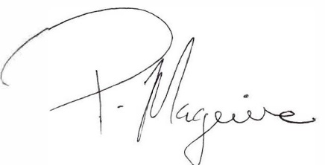
___________________
Padraig Maguire
Senior Planner/ A/ Director of Services.

https://ec.europa.eu/energy/topics/renewable-energy/directive-targets-and-rules/renewable-energy-directive_en#directive-2018-2001-eu.
http://www.npws.ie/media/Biodiversity%20Plan%20text%20English.pdf

